BELEZOS CRIANZA 2014
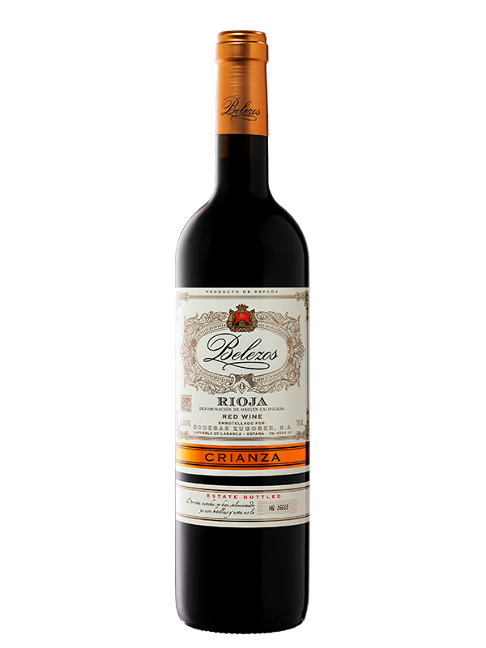 | Region: Rioja Alavesa  Grapes: 95% Tempranillo, 5% Graciano, Mazuelo  Vintage: 2014  Ageing: 14 months in American Oak  Tasting Notes: Garnet red colour with ruby highlights. Clean and intense aromas of red fruits and spicy background from the oak. Full flavoured, long lasting on the palate, ripe fruit flavours.  Food Pairings: Roasted red meats and stews. Game, Duck, Roast Lamb.

