SIN PALABRAS ALBARIÑO 2017
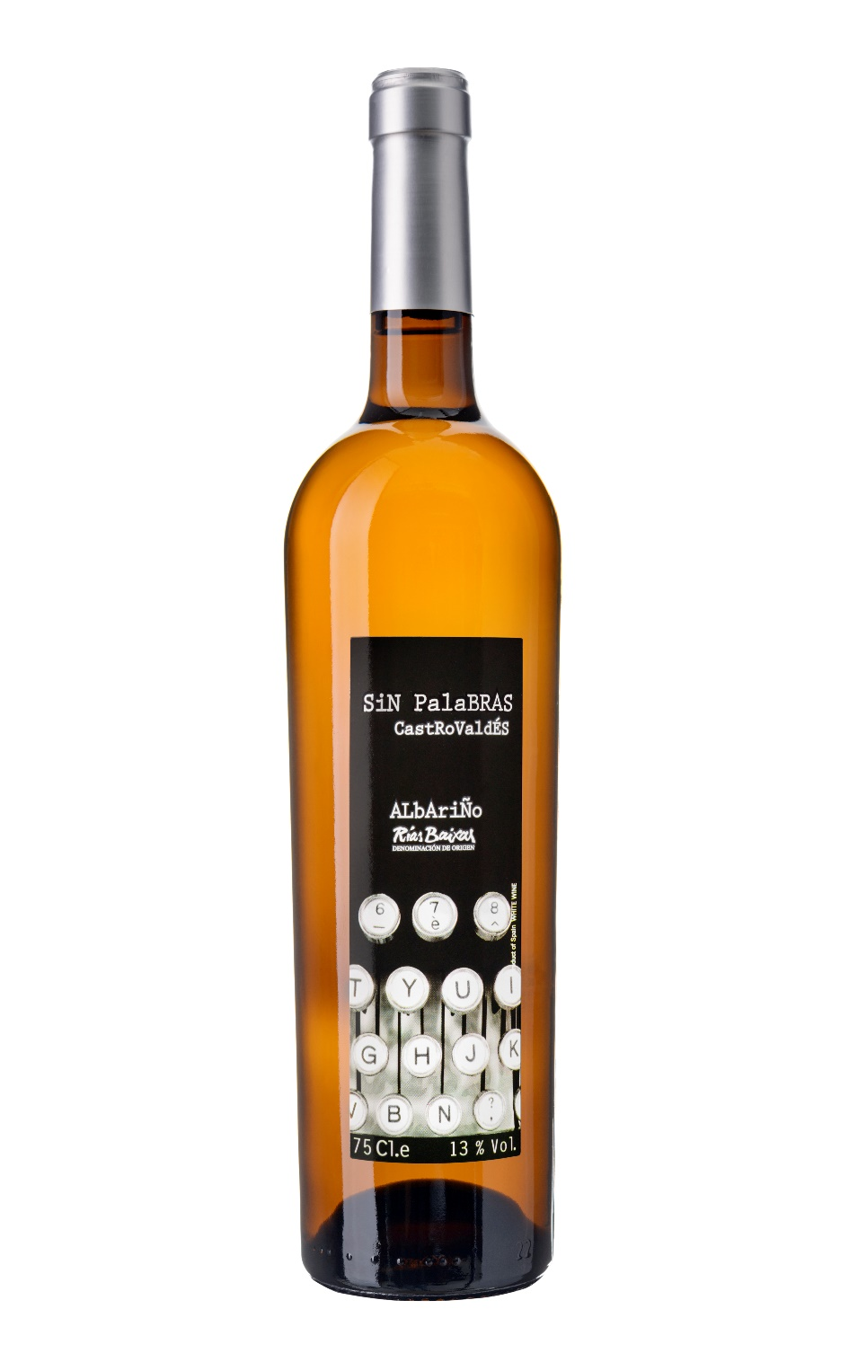 | Region: Rias Baixas  Grapes: 100% Albariño (50 years old vines)  Vintage: 2017  Ageing: On fine lees in stainless tank for 2 months.  Tasting Notes: Straw yellow colour, clean and brilliant. Fresh fruit and white flowers aroma. Mineral, Fresh and perfectly balanced with the acidity.  Food pairing: All kind of seafood. Ceviches, Oysters, Sushi and seafood pastas.

