Dehesa de Luna Origenes 2015
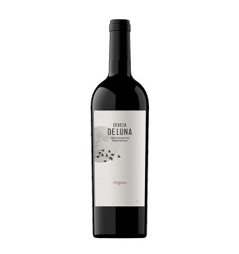 | Region: Vino de la tierra de Castilla(Castilla la Mancha).  Grapes: 38%  Tempranillo, 29% Syrah, 33% Cabernet Sauvignon.  Vintage: 2015  Ageing: 6 months in 90% French Oak and 10% American Oak.  Tasting Notes: Scarlet red colour. In the nose there is forest fruit along with strawberry. In mouth is robust, with volume, mature tannin with an earthy texture. A vivid ,fine and elegant wine.  Food Pairings: Game, Roast and stewed lamb dishes, chicken stew.

